Experiment 6: Windows Operating System Commands Execution
Aim: To study and execute network commands such as tracert, ping, ipconfig, and netstat in the Windows operating system.
Procedure:
- Open the Windows Command Prompt.
- Type tracert www.saveetha.com and press Enter to trace the route taken by packets to the destination.
- Type ping www.saveetha.com and press Enter to check network connectivity.
- Type ipconfig and press Enter to display the system's IP configuration.
- Type netstat and press Enter to display active network connections and related information.
- Observe and record the output of each command.
Screenshots:
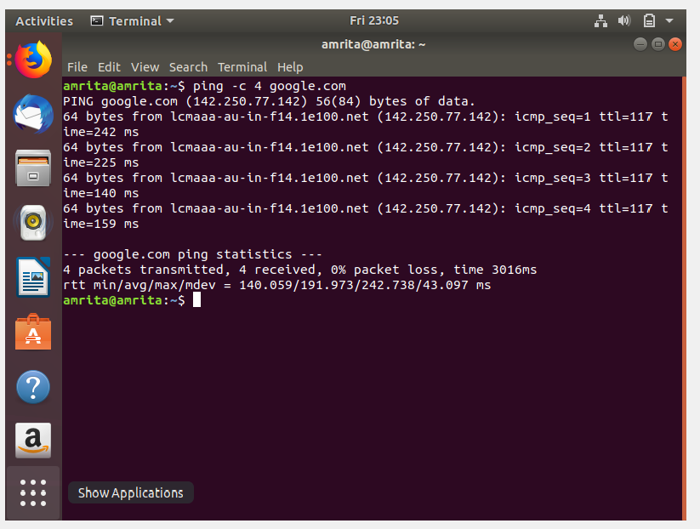
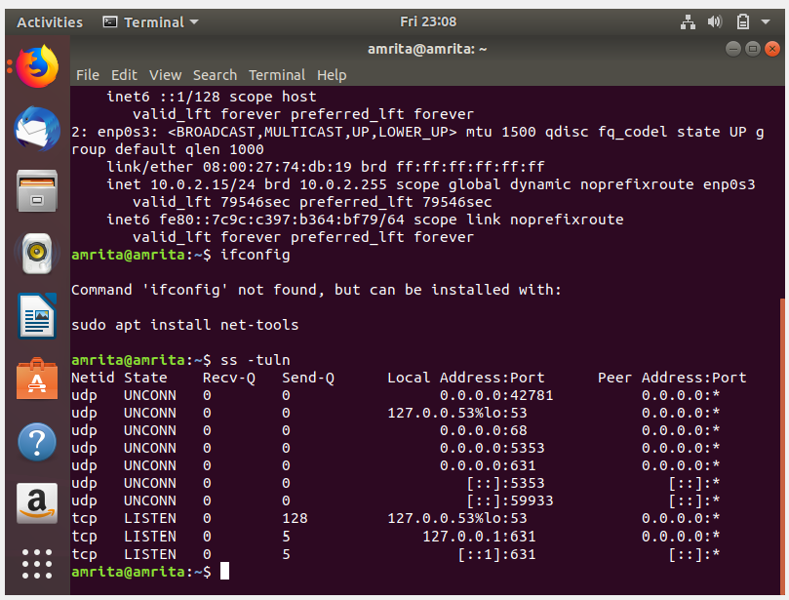
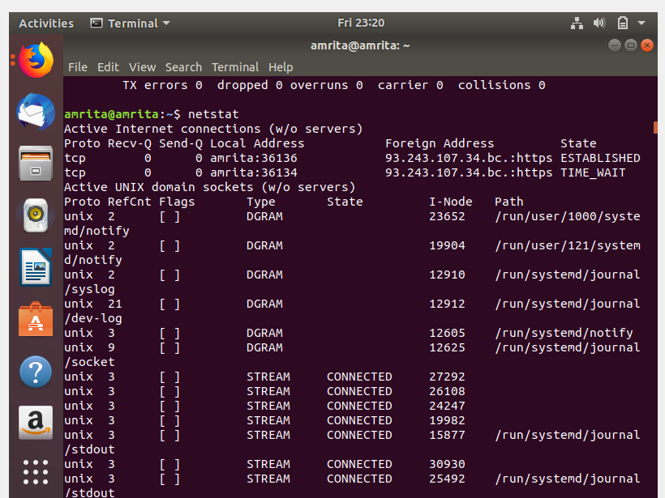

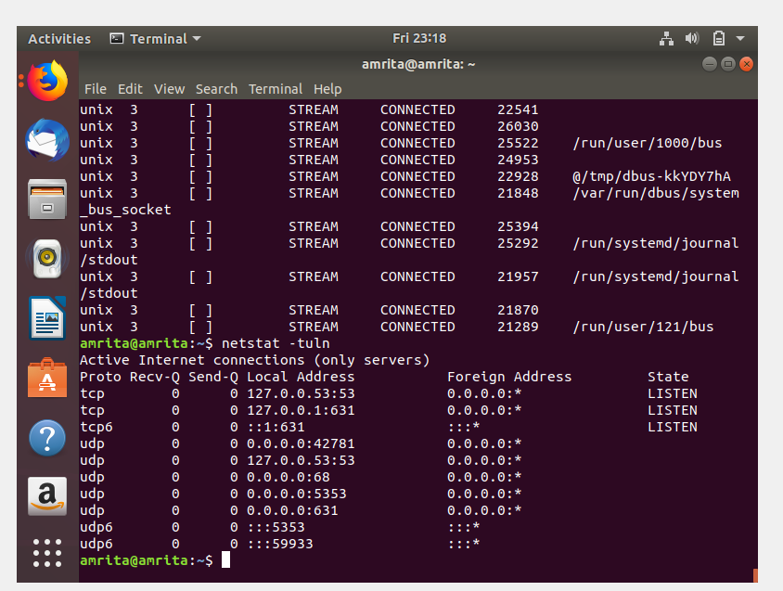

Result:
Thus, network commands were executed successfully to examine network connectivity, packet routes, IP configuration, and network connections.

